Erasmus+ MOBILITY AGREEMENT FOR SCHOOL STAFF and QUALITY COMMITMENT for school education

I. DETAILS ON THE PARTICIPANT

Name of the participant: Anghel Lavinia
Sending institution (name, address): Liceul Tehnologic Eremia Grigorescu, Mărășești
Contact person (name, function, e-mail, tel): Dragomir Alina, Project manager, gagualina@yahoo.com, alina.dragomir@teachforromania.ro, +40747775624

II. DETAILS OF THE PROPOSED PROGRAMME ABROAD

Receiving organisation (name address): ITEACH ITL INSTITUTE
Contact Person (name, function, e-mail, tel): SALIH CATAL, MANAGER. info@itl-institute.com , +90 505 853 63 67

Planned dates of start and end of the mobility period: March 09 – 18 March 2020

Detailed programme of the mobility period:
Day 1 – MONDAY
Welcome and registration
Introduction to the Concept of Early School Leaving
Learning the Basic Terms about Early School Leaving
What is Meant by Early School Leaving
Who is (not) considered to be an Early School Leaver
What is the EU Objective Regarding ESL?
Why do Young People Abandon Education Early?

Day 2 – TUESDAY
3 Steps in ESL Process: Prevention, Intervention and Compensation
„Should I Stay or Should I Go“ – Students' Dilemma – ESL from Students' Perspective
Examples of Good Practices of Tackling ESL from European Countries

Day 3 – WENDESDAY
The Power of Teachers – How Much Teacher Can Influence on Preventing ESL?
Practical Exercises Aimed at Strengthening Students' Self-Esteem
Practical Exercises for Improving Your Teaching Style

Day 4 – THURSDAY
The Importance of Parental Involvement in Their Childern's Education
Early School Leaving in Multicultural Society
Link between Migration and Early School Leaving
Strategies for Conflict Resolution in the Classroom

Day 5 – FRIDAY
Practial Exercises Aimed at Students with Special Needs
Project – Based Teaching: My 6 Months' Plan for Tackling ESL
What is Your Learning Style – How Can Change of Learning Style an Help to Preven Early School Leaving

Days 6/7 – SATURDAY and SUNDAY Workshops and Cultural/Sightseeing Activities
Day 8 – MONDAY
Multiplle Intelligence Theory – Every Child is Unique
Role of the Teacher is Crucial for Student Staying in School – Debate
Learning the Empathy – Try to Feel What Your Student Feel – Role Play
How to Tackle Behaviourally Challenged Children – The Art of Discipline

Day 9 – TUESDAY
The Importance of School Environment: How to Make Your Classroom Attractive for Students
Learning through Playing; Learning Can be Fun
The Conclusion: Focus on the Solution, not the Problem

Day 10 – WEDNESDAY
Feedback, Course Evaluation and Dissemination Focus
Certificates
Tasks of the participant before, during and after:
Before:
There are preparation activities in which the participant is involved, organized/overseen by the Sending Organisation’s:
- Linguistic preparation
- Application for the Europass
- Filling in of Learning Agreements
- Liaison with Receiving Organisation regarding accommodation, etc
Tasks/preparation required by course provider:
1. To prepare training programs and pay attention to quality of education,
2. Officially approving commitments in the grant contract
3. Assigning Contacts
During:
An interactive communicative approach is applied, which provides participants with experiential learning. Participants develop their fluency through discussion about current affairs and topics of general interest. Input sessions are in the form of hands-on workshops or discussions for fluency work, and involve brainstorming, analysis, problem-solving, and roleplay, both in pair-work & group work. Participants are actively involved in the sessions to maximize their learning and to experience activities from their learners’ point of view.
1. Organizing the Training in English
2. Preparing the course content and activities according to the needs of the participants and the objectives of the project.
3. Guiding participants
4. Organizing cultural excursions
5. Responsible for the safety of the participants
6. Preparing the necessary certificates and Europass documents related to the course at the end of the course
After:
Trainees will be given soft and hard copies of all lesson materials, which they can present to their colleagues in their own organizations to generate interest in project writing. In addition, a mailing list of participants will be created in order to exchange ideas/experiences. At the end of the course the participants will fill in a questionnaire in order to get a detailed feedback for the effectiveness of the training event.
Competences to be acquired by the participant:
Introducing the basic terminology related to early school leaving
Familiarizing with the EU policies about early school leaving
Reflecting upon examples of good practices from different European countries related to the topic
Identifying the causes leading to early school leaving
Practicing activities aimed at boosting the students’ motivation
Improving communication between stakeholders involved in education: parents, teachers, students
Understanding the mechanism of school leaving prevention
Integration with teachers from various European countries
Improvement of language and communication skills
Increased capacity to cooperate on international level
Getting practical ideas for applying in classroom
Enhanced intercultural awareness
Broader understanding of practices, policies and systems in education
Encouragement of sharing best practices, ideas and materials between colleagues within the EU
Development of tools and techniques for innovative problem solving.
Monitoring and Mentoring of the participant before, during and after the mobility:
The course organisers will send to the participants a list of materials related to the course topic that they can read in order to prepare for the course (such as Erasmus + Guide for 2019). The organisers will assist the participants if they need information related to the accommodation, plane tickets or other necessary details. Trainees will be given hard copies of all lesson materials, which they can present to their colleagues in their own organizations to generate interest in 21st-century teaching methods with creative thinking. In addition, a mailing list of participants will be created in order to exchange ideas/experiences. Self-evaluation materials will be provided.
Evaluation and Recognition of the mobility:
The course is evaluated with a questionnaire after the course conclusion, as well as from the feedback received from the participants during the mobility. Recognition of the mobility is arranged by issuing a Europass mobility document, issued together by the sending and receiving organization.
A course participation certificate will be given to all participants.

III. COMMITMENT OF THE PARTIES INVOLVED

By signing this document, the participant, the sending organisation and the receiving organisation confirm that they will abide by the principles of the Quality Commitment attached below.

THE PARTICIPANT
Participant’s signature

........................................................................... Date:

THE SENDING INSTITUTION
We confirm that this proposed mobility agreement is approved.
On completion of the mobility the institution will issue a Europass Mobility to the participant

Coordinator’s signature  ...................................................................... | Date:

THE RECEIVING ORGANISATION
We confirm that this proposed mobility agreement is approved.
On completion of the mobility the organisation will issue a Certificate of participation to the participant
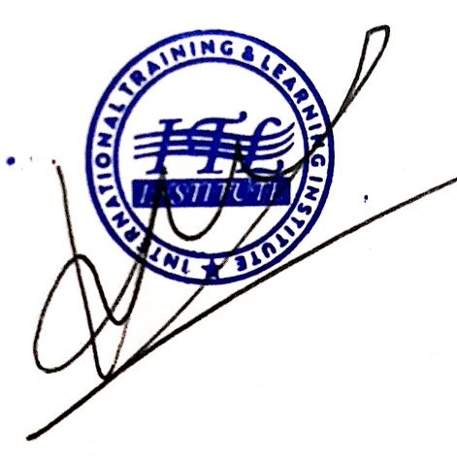  Coordinator’s signature  ............. ................................................................. | Date:

